Yukon-Kuskokwim Housing Resources Guide & Regional Directory
A tool for residents, researchers, housing providers, and organizations addressing housing needs in Alaska’s YK Delta region
Introduction 3
Organization 4
Methodology 5
Rationale 5
Related resources 8
Regional Entities 8
Tribe and Alaska Native Corporation 8
Local Tribes, Cities, and Village ANCSA Corporations 9
Housing Authorities 11
Alaska Native Tribal Health Consortium (ANTHC) 13
Coastal Villages Region Fund 13
Kulsivak Rising 14
Alaska Institute for Justice Climate Justice Program 15
Vendors/Businesses 15
Design Firms 16
Contractors and Builders 16
Owner’s Agents 16
Building Materials Transportation 16
Project Management and Consulting Firms 17
Utility Providers 17
Alaska-based Non-Profit Organizations 19
State Government Agencies 20
Disaster Response 20
Federal Agencies 22
The Denali Commission 22
Denali Commission Village Infrastructure Protection 22

Glossary/Acronyms
Agnew::Beck: Long-time Alaskan consultant firm that does a great deal of work with
housing (e.g., produced the AVCP RHA Housing Needs Assessment)

AAHA: Association of Alaska Housing Authorities https://www.aahaak.org/
AHFC: Alaska Housing Finance Corporation https://www.ahfc.us/
ANC: Anchorage
AKCH2 Alaska Coalition on Housing and Homelessness
https://www.alaskahousing-homeless.org/
ASRC Alaska Slope Regional Corporation https://www.asrc.com/
AVCP: Association of Village Council Presidents https://www.avcp.org/
AVCP-RHA Association of Village Council Presidents Regional Housing Authority
https://www.avcphousing.org/
CCHRC Cold Climate Housing Research Center www.cchrc.org
CWAT: Community Winter Access Trail
https://www.north-slope.org/departments/housing/shipping-assistance/cwat-alternative-shipping-assistance/
IHBG: Indian Housing Block Grant
https://www.hud.gov/helping-americans/public-indian-housing-ihbg
NREL National Renewable Energy Laboratory (Alaska Campus)
https://www.nrel.gov/about/alaska
NSB: The North Slope Borough https://www.north-slope.org/
RHA: Regional Housing Authority
TNHA: ​​Tagiugmiullu Nunamiullu Housing Authority https://tnha.info/
UIC: Ukpeagvik Inupiat Corporation https://uicalaska.com/
YKD: Yukon-Kuskokwim Delta
YKR (Y-K Region)

Introduction
This Housing Resources Guide is being developed to serve as a resource for individuals and organizations either located in or working with the Yukon-Kuskokwim Delta region as they navigate home design, building material procurement, construction, maintenance, and repair in remote Alaska, including planning for managed retreat and relocation scenarios. This 2026 guide is an initial, small-scale version of a product envisioned as an updatable (living) online resource.

The Yukon-Kuskokwim Delta area is also referred to as the Yukon-Kuskokwim Region, or YKD, or Y-K Delta, or YK Delta. The region comprises the Bethel and Kusivaluk census areas and is also called the Calista Region, after its regional Alaska Native Claims Settlement Act (ANCSA) corporation, the Calista Corporation. Several communities in the region are upriver of Bethel on the Middle Kuskokwim River and are not geographically located in the Delta. The region is sometimes organized into 4 sub-regions: Coastal, Lower Yukon, Lower Kuskokwim, and Middle Kuskokwim. The regional tribal consortium, the Association of Village Council Presidents, refers to the region as the YK Delta, which is the name used in this directory.

The YK Delta is the heart of the Yup’ik nation. The Yup’ik of the YK Delta speak Central Alaskan Yup’ik, and the two dialects spoken in the region are Yup’ik and Cup’ik. The actual delta formed by the two rivers is a broad, marshy plain created from silt accumulated from the Yukon and Kuskokwim rivers. Anthropologist Ann Fienup-Riordan writes that, aside from the volcanic domes of Nelson and Nunivak islands, “[t]his vast alluvial prairie is criss-crossed by innumerable sloughs and streams that cover close to half of the surface of the land with water and create the traditional highways of its native population”.

The YK Delta encompasses approximately 58,000 square miles (about the size of New York State) and is characterized by many small villages. Approximately 25,000 residents are spread across 48 communities, including 56 federally recognized tribes. While the regional hub of Bethel has over 6,000 residents, 45 communities in the YK Delta have fewer than 1,000 residents.

We call some of our communities “hubs.” Hub communities are a little larger than their surrounding communities and their runways allow for large jets to land. The regional hub (the YK Delta hub) is Bethel, Alaska. - AVCP
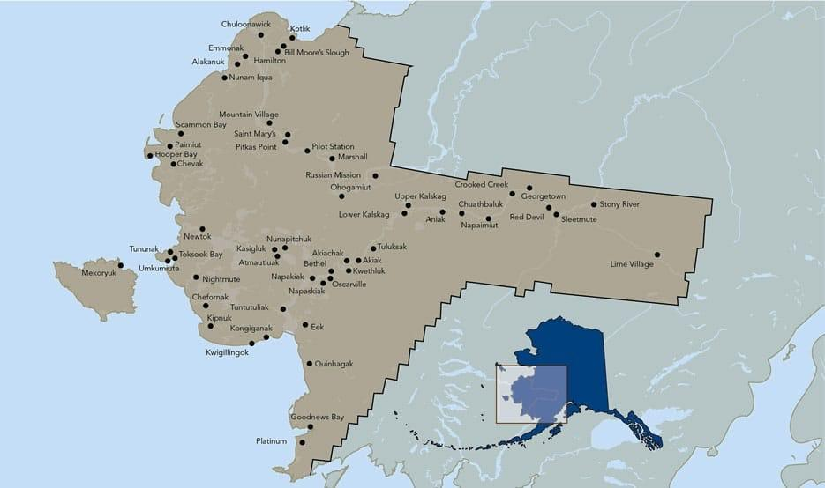

Image 1: Web links to this quote can be found in Endnote 1.

Organization
After this introduction, the guide briefly describes local communities, then regional tribal and ANCSA corporate entities, housing authorities, and other regional entities. The second section covers housing resources: relevant vendors/businesses, utility providers, non-profits, and state and federal agencies.

The guide provides examples throughout of specific entities’ involvement in housing. A typical housing project likely involves several local, regional, state, and federal organizations, and these examples illustrate aspects of the complex housing network.

The final section in this guide is a directory for the YK Delta. It includes the 48 communities in the region with a brief overview of each village’s location, population, and environmental risks followed by contact information for the main entities in each community. The directory also notes whether a community is a member of the regional housing authority and, if it has its own tribally designated housing authority, provides that organization's contact information.

Methodology
Creating the first sections of this guide involved traditional research (e.g., published anthropological works) and traditional online sources (primarily the entities' own websites). To initially identify many entities and to track their activities associated with housing, as well as their connections to other entities involved, we followed leads from news articles (qualitative media analysis) and cast wide nets on social media - a methodology that can be referred to as social media monitoring.

Much of the information in this guide depended on our own housing network. Our longtime housing research partner, Jerilyn Kelly, is a Yup’ik leader from the community of Quinhagak, where she is currently City Mayor. Kelly is routinely requested to ground-truth statements, review drafts, and advise on research directions. Our research participant Kari Mejorado is the director of the Native Village of Unalakleet’s Housing Department. Unalakleet is north of the YK Delta, but Mejorado’s work overlaps significantly with this effort, and she has helped define what kind of guide would be useful for people in similar positions. Author Fritz, an applied anthropologist of Arctic infrastructure, has worked with the Cold Climate Housing Research Center (CCHRC), a Fairbanks-based organization described in the Alaska-based non-profits section, and has had projects in several YK Delta communities. Fritz’s husband, Ryan Tinsley, a builder and building system innovator, is a CCHRC consultant and has worked on projects in several YK Delta communities. Authors Nicewonger and Fritz have collaborated on housing research in rural and remote Alaska since 2020.

The regional directory in the final section was inspired by a region-wide North Slope Borough (NSB) directory that, until 2012, was updated annually and was invaluable for coordination in that region. The YK Delta regional directory included here was compiled with the help of ChatGPT, the large language artificial intelligence model. That effort was illuminating - we provided the NSB directory as an example and used a straightforward series of prompts to request a YK Delta version. Th request seemingly “broke” the AI, which eventually produced several long and differently incomplete documents that we then combined into one directory. Vetting the directory for accuracy and designing an online version that can be updated are ongoing projects.

Rationale
The YK Delta is one of Alaska’s regions with the greatest need for housing, and it has numerous environmentally threatened villages that are either protecting in place, undertaking managed retreat, or planning to relocate entirely. Economically, the YK Delta is Alaska's poorest per-capita region, and its residents are among the most dependent on subsistence resources. Poverty and unemployment rates in the region, excluding Bethel, are among the highest in the nation. Unlike Alaska’s relatively wealthy North Slope or Northwest Arctic regions, the YK Delta has no incorporated borough that could spearhead certain regional resources.

Many organizations included here serve Alaskans statewide. Other regions with housing challenges similar to the YK Delta could benefit from a building guide, but Alaska is vast and diverse. To be useful to any one region, a guide must attempt to drill down into the specific players, geographies, and environment relevant to each community.

Because a comprehensive repository for remote Alaska home designs, building techniques, or housing entities does not yet exist, good building techniques, fabricators, specialists, material choices, and innovations go undocumented and unshared among housing providers. As importantly, numerous lessons learned about bad building materials, outdated techniques, and corrupt contractors to avoid should be shared. Homes in remote Alaska tend to include specialty materials and techniques that no typical U.S. home needs, on top of the remote logistics, climate, and different ways of life, like subsistence processing, that mean homes are used very differently. This leads to isolated progress: one community or construction crew figures out a good practice, but it does not always spread to other communities or crews.

A Fairbanks builder was inspired by an innovative cold-climate SIP (structural insulated panel) design option explained in a blog post on the Premier SIPs website, but could never find anything else on it. He was glad to see the design applied on the new school in Kivalina, then heard it was being applied in Dillingham. Later, a non-professional builder in SE Alaska, who had read the same blog, sent him hand-drawn sketches and questions about whether it had been evaluated. It was frustrating that individuals across the small Alaska building community did not have a systematic way of sharing important Alaska-specific information.

The underlying goal of the Native American Housing and Sovereignty Act (NAHASDA), described in more detail below, was to give tribes more decision-making power in housing. NAHASDA has been more successful than previous, disjointed, and top-down housing programs for Alaska Natives and American Indians. At the same time, the responsibility for planning, funding, permitting, contracting, and successfully navigating an effort like building a new subdivision, much less a complete village relocation, is typically beyond the capacity of small tribal governments and villages. The complexities and pitfalls typical of such situations were detailed in a spring 2025 series of investigative news stories by Bethel-based public radio KYUK’s Emily Schwing, who explored problems with Newtok’s new relocation housing in Mertarvik. That investigation suggested that placing ultimate responsibility for such projects with a community’s small handful of adults - who take turns serving on the tribal council while managing their own families, jobs, and subsistence harvests - is highly problematic.

Dozens of grants from at least seven federal agencies have helped pay for the relocation, which began in 2019 and is expected to cost more than $150 million. But while the federal government supplied taxpayer dollars, it left most of the responsibility to the tiny Newtok Village Council. The federally recognized tribal government lacked the expertise to manage the project and has faced high turnover and internal political conflict, according to tribal records and interviews with more than 70 residents as well as dozens of current and former members of the seven-person village council. - Emily Schwing, May 29, 2025, “Newtok was supposed to be a model for climate relocation. Here’s how it went wrong.”
KYUK & ProPublica

Image 2: Web links to this quote can be found in Endnote 2.

Thus, while one purpose of this directory is to facilitate home construction and maintenance, another goal is to illustrate that navigating this complicated network of bureaucracies and other entities to successfully build new homes - even when there is funding for it - is overly complicated. Nearly every report on environmentally threatened communities in Alaska has noted that no single government agency is responsible for relocation (e.g., ANTHC 2024). Other articles have noted that although thawing permafrost is one of the core environmental threats damaging housing and imperiling communities in the YK Delta, it is not recognized as a natural disaster.

"Damages to infrastructure caused by permafrost thaw is on par with the average yearly cost of all natural disasters in the country, yet permafrost thaw is not recognized by the federal government as a natural hazard making it harder for people in Alaska to obtain disaster relief funding." - Anne Liljedahl Woodwell Climate Research Center.

Work on this guide was underway when the remnants of Typhoon Halong struck the YK Delta on Oct. 12, 2025, resulting in a disaster declaration, FEMA funds, and Alaska’s first modern climate refugees, as over 1,600 people were displaced. An estimated 52 communities reported damage, and around a dozen reported significant damage. The Alaska Department of Homeland Security reported that 208 homes were destroyed and 471 sustained major damage.

Since Halong, an increased focus on emergency housing solutions and the likelihood of village relocation have brought broader attention to housing security issues in the YK Delta. The worst-hit communities are weighing what to do while they process the information that FEMA and disaster response agencies cannot relocate communities (e.g., Smith 2026) and that, if they should decide to relocate, it will be even more difficult for them to secure funding for infrastructure in their existing community (as well as very difficult to get funding for infrastructure in any new relocation community).

Related resources
This current focus on housing is one in a long and growing list of projects that have addressed the broader issue of climate-induced village relocation in the YK Delta and other regions of Alaska. The summary below is incomplete but shows that the complexity and expense of housing security and relocation are serious problems.

The late lawyer Robin Bronen, co-founder of the Alaska Institute for Justice and its Alaska Climate Justice Program, researched climate-induced relocations as a Senior Research Scientist at the University of Alaska Fairbanks (UAF) since 2007. Bronen and many others have repeatedly highlighted the lack of a single coordinating agency. Anthropologist Elizabeth Marino turned her UAF doctoral dissertation into a 2015 book (“Fierce Climate, Sacred Ground”), essentially a “how-to” guide for village relocation. Marino has published extensively on environmentally forced migration in Alaska and elsewhere. Mindy O’Neall, currently Mayor of the City of Fairbanks and previously director of CCHRC, did her MA in Public Administration at UAF focused on the governance of relocation in Alaska. The Denali Commission (described below) funded a project to study the problem years ago. Lawyer Mara Kimell, currently the Director of the Alaska Chapter of the ACLU, wrote a dissertation on the complexity of land issues in the YK Delta. University of Alaska Anchorage graduate student Claire Baldwin Jorgenson, formerly at the Alaska Field Office of the Department of Housing and Urban Development (HUD) and currently a program manager at the Denali Commission, is working on a PhD on village relocation. Olivier Pfeifer is a rural energy project manager at the Alaska Native Tribal Health Consortium (ANTHC, described below) and completed a Master of Public Administration in Public Policy Analysis at the University of Alaska Anchorage, where he studied this issue. Janelle Tingook, from Point Hope, is a graduate student in public administration who is researching the administrative processes of village relocation. Alaska Climate Justice Program Director Sheryl Musgrove is her client and, for her MA thesis, Tingook is using a community in the process of relocating as a case study and creating a graphic depicting all the organizations that need to cooperate to move the process forward.

Regional Tribe and Alaska Native Corporation

The Association of Village Council Presidents (AVCP) is the YK Delta region's non-profit tribal consortium. AVCP was created in 1964, before and in preparation for the Alaska Native Claims Settlement Act (ANCSA), and is currently the ANCSA non-profit Native association for the YK Delta.

The Calista Corporation (“Calista”) is the regional for-profit ANCSA corporation for the YK Delta. In some regions, the for-profit regional ANCSA corporations have established subsidiary home construction companies.

The Yukon-Kuskokwim (Y-K) Coalition was formed by regional organizations that cooperate to support the Y-K Delta. Partners include but are not limited to Calista Corporation, Association of Village Council Presidents (AVCP), AVCP Regional Housing Authority, Coastal Villages Region Fund, the Yukon Delta Fisheries Development Association, and more. Leaders from Tribes and Village Corporations have also joined the Y-K Coalition’s advocacy efforts over the years.

A recently established entity whose goal is “to unite the 56 tribal entities within the YK Delta” is the Yukon-Kuskokwim Regional Tribal Government (Y-K RTG), but to date this entity lacks full regional participation and has taken little action.

Local Tribes, Cities, and Village ANCSA Corporations

For entities and individuals outside the YKD, navigating any aspect of housing construction in the region requires awareness of and flexibility with specific community entities, events, and schedules. Coordinating with local entities for permission and guidance is common for anyone working on any type of project in Alaska. In a small community, a project may require coordinating with the local Tribe, city administration, and village ANCSA corporation. Many communities do not have an incorporated city, and thus the Tribe and village ANCSA corporation are the main entities. Please refer to the YK Delta Region Directory, the third section of this guide, for the entities for each community.

In some regions, multiple villages have combined their village corporations into a single subregional corporation, such as The Kuskokwim Corporation (TKC). TKC is the combined village corporation for 10 communities in the Middle Kuskokwim. ANCSA corporations often have both for-profit and non-profit subsidiary corporations, and TKC Fish Wheel is an example of the latter. TKC Fish Wheel was created to secure funding for business opportunities and infrastructure development projects, and it leads the Middle Kuskokwim “Harvest to Home” project, which is establishing a specialized lumber mill and standardized timber-based home packages.

Tracking dates and aligning with each community’s standing city and tribal council meetings, for example, can help schedule housing meetings and design charrettes without adding bureaucratic burdens. Subsistence practices are vital for the well-being of remote Alaska communities and should play an integral role in planning housing design and construction, repair, and maintenance activities in the region. Anyone working with a specific community should review that community’s subsistence reports. The Alaska Department of Fish and Game Division of Subsistence technical reports usually provide information on a community’s subsistence harvest schedule, which could be incredibly relevant for construction projects (e.g., consider not scheduling a two-week period of intense local labor in a community during the same time frame that that community is occupied with harvesting specific fish or game species that are only accessible during those dates).

The YK Delta Region Directory is included as the third section of this guide because comprehensive contact information for the YK region is difficult to find. Any such directory is inevitably out of date: administrative assistants turn over quickly, and entities change email addresses, so having easy access to an entity’s phone number is convenient. Existing online resources for YK Delta Tribes include:

- The Association of Village Council Presidents (AVCP) maintains a Yukon-Kuskokwim Region Tribal Office Directory, an alphabetized, searchable spreadsheet that includes the federally recognized name of the Tribe, each Tribe’s “doing business as” name, phone and fax numbers, and mailing addresses. Users can search by Tribe name or community name. The URL is https://www.avcp.org/contact-us/

- The Bureau of Indian Affairs (BIA) provides a Tribal Leaders Directory, a nationwide geospatial database (“geoplatform”) where users can search for a contact by name or location, or zoom in on the map and click. The pop-up info for each Tribe includes mailing address, name of President/Chief, phone and email, and election dates. If the Tribe has a website, the linked URL is provided in the “Contact” information, but not in the pop-up information that appears when a user clicks on the Tribe on the map.

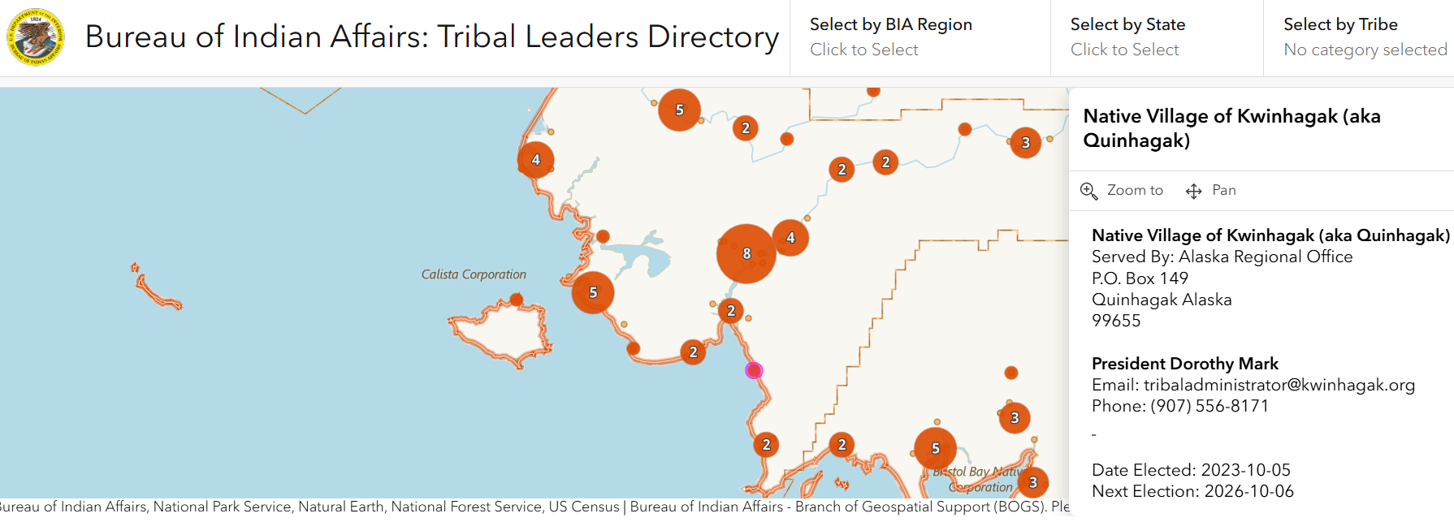

This BIA database comes with instructions, and the geospatial map database allows users to search by the name of the Tribe but not the name of the community, which could make it less useful for some. For example, a search for Mountain Village returns no results. A user can search for the Asa'carsarmiut Tribe, click the highlighted point (the geoplatform does not automatically zoom in), and see that the Asa'carsarmiut Tribe is in Mountain Village. A user could search for Mountain Village in the Contact search bar and find the Asa’carsarmiut Tribe that way. Using the map alone, users can find a Tribe by community name only if the names match or the Tribe’s name includes the community’s name. The URL is https://biamaps.geoplatform.gov/Tribal-Leaders-Directory/

Relevant for relocation research, the BIA Tribal Directory geoplatform shows the community of Napaskiak located entirely within the Kuskokwim River. (The community of Napaskiak previously included many acres of land that have been eroded by the Kuskokwim.)

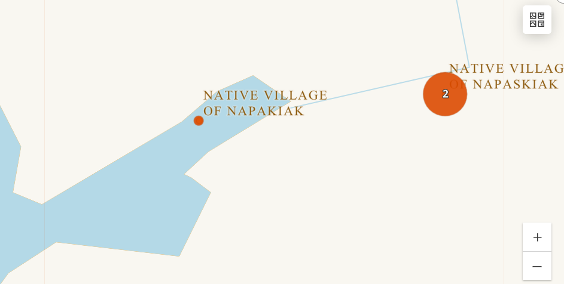

- Wikipedia is a good source for information on YK communities (both incorporated cities and census-designated places - CDPs), but it does not provide the names of Tribes or any entity contact information. It does provide city mayors' names and potentially relevant information about the surrounding environment and history.

Housing Authorities

In 1996, the Native American Housing Assistance and Self-Determination Act (NAHASDA) became law. NAHASDA reorganized and standardized how housing assistance is provided to Tribes, giving them greater sovereignty and allowing them to manage funds according to their own priorities. Several previous programs were combined into the Indian Housing Block Grant (IHBG) program division at the Department of Housing and Urban Development (HUD). NAHASDA established that federal assistance for tribal housing could be made directly available to Tribes or to Tribally Designated Housing Authorities. The Indian Community Housing Block Grant (ICHBG) program is part of the broader Indian Housing Block Grant (IHBG) program.

Alaska’s Tribally Designated Housing Entities (TDHEs) include both regional housing authorities and community- (Tribe-) specific housing authorities. Alaska has 12 regional housing authorities (RHAs) that provide services for tribes in their corresponding 12 ANCSA regions. Each Tribe can choose to join its regional housing authority or establish its own community housing authority. Because RHAs can build homes in only a few communities per year, an individual Tribe/community may conclude it can secure its own funding and build more new housing more quickly by opting out of its RHA and establishing its own, community-specific, tribally designated housing authority. For example, the community of Quinhagak was originally a member of AVCP RHA, then managed its own housing authority for several years, and then rejoined AVCP RHA.

The 12 Regional Housing Authorities are members of the Association of Alaska Housing Authorities (AAHA), and each RHA's Executive Director serves on AAHA's Board of Directors, which also has an Executive Director. Griffin Forster is the current Executive Director of AAHA and previously served as ED of the North Slope’s regional housing authority. AAHA is headquartered in Anchorage and is co-located with the Alaska Housing Finance Corporation (AHFC).

AVCP Regional Housing Authority (AVCP RHA) is the tribally designated housing authority for the YK Delta. AVCP RHA serves 48 communities and 51 Tribes in 56 villages in the YK Delta. AVCP RHA produced a Housing Need Forecast as part of its 2024 Strategic Plan that provides an excellent assessment of funding shortfalls, opportunities, and input from various housing providers. (AVCP RHA developed its Housing Need Forecast before ex-Typhoon Halong damaged or destroyed scores of homes in the region.)

AVCP RHA headquarters are in Bethel, but it does not serve Bethel residents. The Orutsararmiut Native Council, the federally recognized governing body for the community of Bethel, is the tribally designated housing authority for the Native Village of Bethel. (The Native Village of Bethel also includes the Bethel Native Corporation, the ANCSA village corporation.)

In addition to NAHASDA funds, housing authorities partner with various entities and apply for numerous types of grants and funding streams because they usually have to stack funding to cover the cost of a single home. AVCP RHA, for example, collaborated with its partner organization, AVCP Housing Improvements Program, to support a federal Dept. of the Interior Bureau of Indian Affairs (BIA) down payment assistance program for a family in AVCP RHA’s homebuyer program. The BIA program assists income-eligible Alaska Native and American Indian families with down payment and closing cost assistance.

The Circle Native Community was awarded an ICDBG (Indian Community Development Block Grant) and decided to use the funds, via the Interior Regional Housing Authority (IRHA), on new construction due to a housing shortage. Construction was scheduled for 2020-’21, but the COVID-19 pandemic led to construction delays and significantly higher material costs. The ICDBG no longer covered the post-pandemic costs, so IRHA cobbled together additional funds to see the project through, including an annual allocation from AHFC, a donation from Mt. McKinley Bank, a one-time pass-through grant with AHFC funds from CCHRC ($25K), $2K from Wells Fargo, and some internal programming funds.

Finally, although most housing in the region is some form of public housing, it is not uncommon for community members in the YKD to initiate their own home-building project.

Alaska Native Tribal Health Consortium (ANTHC)
Established in 1997, ANTHC is a consortium of Alaska’s tribal regional health organizations that provides health services to 158,000 Alaska Natives and American Indians in Alaska. ANTHC is part of the Alaska Tribal Health System and is one of 22 co-signers of the Alaska Tribal Health Compact, a self-governance agreement with the Indian Health Service. Since its establishment, ANTHC has developed numerous departments that address holistic aspects of rural Alaska Native health, including water and sanitation and indoor air quality. ANTHC’s Climate Initiatives organization worked with state and federal agencies for years to support Newtok’s relocation to Mertarvik.

In 2022, ANTHC and the National Oceanic and Atmospheric Administration (NOAA) announced a new pilot project to support Alaska Native communities' resilience to climate change. The project, “Expanding and Connecting Tribal-Led Climate Change Capacity to Serve Indigenous Community Needs in Alaska,” established a director of Tribal climate change initiatives position at ANTHC to leverage statewide relationships with Tribes. The project’s three objectives are:

- Conduct a landscape assessment of Tribal climate change adaptation activities in Alaska and establish a baseline understanding of Tribal climate change challenges and responses.
- Formulate and launch an Alaska Tribal Climate Change Advisory Group to ensure that Tribal climate change efforts across the State are led and prioritized by Alaska Native people.
- Lead the Tribal review and publication of the Unmet Needs of Environmentally Threatened Alaska Native Villages Report.

ANTHC’s Climate Change Adaptation Program (Don Antrobus, Manager) published The Unmet Needs of Environmentally Threatened Alaska Native Villages: Assessment and Recommendations Report, which seeks to help improve the effectiveness of federal and state governments’ support to Alaska communities. ANTHC’s Center for Environmentally Threatened Communities can be reached at 907-729-4521 or via email at etc@anthc.org
In 2024, NOAA awarded ANTHC a nearly $75 million federal grant to help almost 100 Alaska Native communities impacted by climate change. This is the single largest climate change-related grant to Alaska in history, and the intent was to add at least 20 employees to ANTHC’s staff and create more than 60 positions within tribal communities statewide to focus on local climate issues.

Coastal Villages Region Fund
Coastal Villages Region Fund (CVRF) is the Community Development Quota) organization for the YK Delta. The Western Alaska Community Development Quota (CDQ) Program allocates a percentage of all Bering Sea and Aleutian Islands quotas for certain fish and shellfish species to eligible communities. CVRF includes 20 member communities and serves over 9,000 people, covering 30,000 miles of coastline in western Alaska. It is a nonprofit group that uses its investments in the large-scale fish trawling industry to run social welfare programs, providing numerous benefits to member communities, including some housing and housing-adjacent projects. For example, CVRF partners with communities to help develop federally recognized addressing systems. After ex-Typhoon Halong, CVRF set up a hotline number and offered help with outboards, heaters, ATVs, and snowmachines. They packaged and sent food and essentials, shipped generators, and had their GIS teams contributing drone imagery and mapping support to help assess damage and guide recovery planning. CVRF has a website and is active on LinkedIn.

Kulsivak Rising
Kulsivak Rising is a new hybrid social enterprise non-profit organization that represents the 13 Lower Yukon communities that comprise the Kulsivak census area. The Kulsivak Region is part of the wider YK Delta/Calista region, but it is somewhat distinct from the rest. Geographically, its communities (Alakanuk, Chevak, Emmonak, Hooper Bay, Kotlik, Marshall, Mountain Village, Nunam Iqua, Pilot Station, Pitkas Point, Russian Mission, Scammon Bay, and St. Mary’s) are all north of the Kuskokwim-centric Bethel census area. When representatives of the 13 communities first convened at a summit in 2017, they adopted a motto: “bigger than Bethel, more effective than Nome, and as strong as any major Alaska hub.” Kulsivak Rising’s goal is economic self-determination for the region, the poorest in the state. The entity plans to focus on job creation, climate adaptation, housing and infrastructure, and language and arts revitalization, among other efforts.

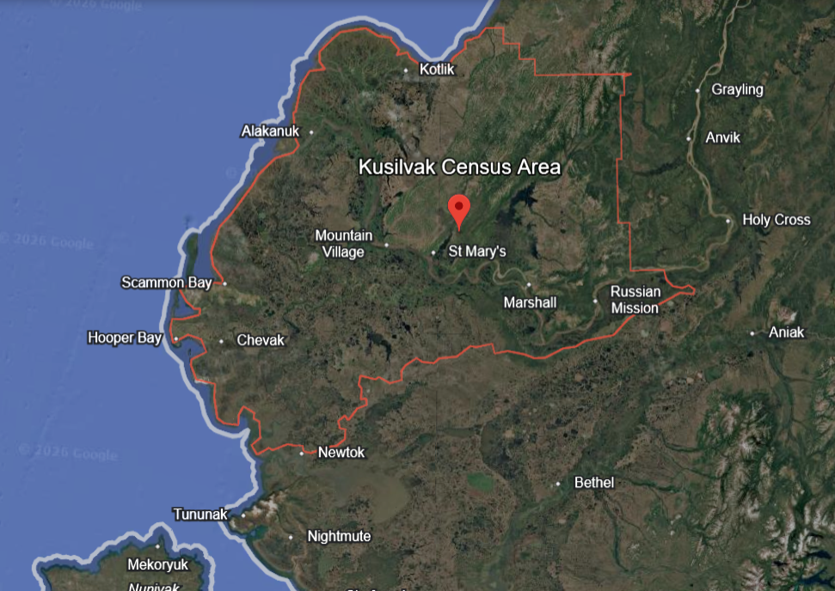

Alaska Institute for Justice Climate Justice Program

Vendors/Businesses

Calista Corporation hosts an online directory of shareholder-owned businesses called Calivika. Calivika (https://calistashareholderbiz.com/) can be updated by business owners and includes drop-down filters that let users search for businesses by type and location. For example, a search on Calivika for home repair turns up the following result:

Mr. Green - home maintenance and repair service.
P.O. Box 1787
Bethel, Alaska 99559
907-545-5067

Design Firms
- Including those specializing in climate-resilient housing.

Contractors and Builders

Securing reputable, ethical, and available contractors and builders is difficult in home construction anywhere. This is less relevant for most home building managed by housing authorities (e.g., AVCP RHA), which hire local crews in each community where homes are built and have regional program managers and crew bosses who travel to construction sites. When Tribes and communities undertake their own projects, results vary.

A well-researched example of an unreputable contractor contributing to housing insecurity is the story of Patrick LeMay in Mertarvik/Newtok (investigated by the KYUK series mentioned above). LeMay won contracts to demolish homes in Newtok, then convinced the Tribe he could build new homes in Mertarvik that were equivalent to the efficient, durable homes designed by CCHRC in the relocation village but would cost much less. LeMay built inadequate gravel pads and shoddy homes that looked, superficially, like the CCHRC homes. Within 1-2 years, the cold, inefficient homes were shifting, and walls were separating from ceilings, among myriad other problems.

When federal funding is secured to construct homes,

Owner’s Agents
Mertarvik/Newtok would have benefitted from a construction owner's agent (also called an owner's representative or owner's rep). is a professional hired directly by a building owner to act as their exclusive advocate and oversee a building project. For example,

Acts as an advocate: Protects the owner’s budget, timeline, and quality goals without any conflicting loyalties to contractors or architects.Manages the team: Vets, hires, and coordinates architects, engineers, general contractors, and specialty consultants.Controls costs: Reviews change orders, approves pay applications, and tracks expenses to prevent cost overruns.Oversees schedules: Monitors milestones and holds all external parties accountable to deadlines.Inspects progress: Acts as the owner's eyes and ears on the job site through regular site visits and quality audits.

Building Materials Transportation

- ADD more examples

- Lynden Barge Service (LAML) https://www.lynden.com/aml/

- Jung & Jordan Trucking (sandpit in Bethel, delivers sand, topsoil, and gravel to residential and business customers within Bethel. This is a very small family-owned business.) PO BOX 1065 Bethel, Alaska 99559 / 907-545-4265

- Spenard’s?

Project Management and Consulting Firms

Communities commonly contract engineering, planning, design, construction, and project management firms to manage and undertake complex projects. For example, the City and Tribe of Napakiak competitively selected Summit Consulting Services as an “Indefinite Delivery Indefinite Quantity” consultant to co-manage the community’s managed retreat. Summit supports all aspects of the managed retreat as desired by Napakiak’s Planning Committee and acts as Napakiak’s “Owner’s Representative” for all activities and contracts throughout the duration of the managed retreat project. These firms are not typically involved in the actual construction of residential homes, but may be managing many aspects of analyses, projects, and permitting that are required to build homes. CRW Engineering, for example, has managed water and sewer projects in Quinhagak, Mertarvik, and Napaskiak, boardwalk improvements in Kipnuk, and the landfill in Eek. (Although it’s not in the YK Delta region, the community of Kivalina’s master relocation plan is managed by CRW). These firms typically subcontract or help the community to contract other specialty firms for specific activities.

- Alaska Adaptable Housing LLC
- [what others?]

Home Inspection Services

- Emmit Leffel

Utility Providers
- Entities managing water, energy, and waste systems critical to housing projects.

Alaska Rural Utility Collaborative (ARUC)

The Alaska Rural Utility Collaborative (ARUC) is a statewide program that partners with communities to manage, operate and maintain water and sewer systems in rural Alaska. We empower communities to sustainably provide safe water and sanitation services through our two types of ARUC membership: the Assisted Billing Program and the full ARUC membership program. Read below for further details.

Alaska Village Electric Cooperative (AVEC)
https://avec.org/

Direct phone line: (907) 561-1818
Toll-Free: (800) 561-1818
Fax: (800) 478-2389
General email address: memberinfo@avec.org
AVEC Board of Directors: board@avec.org

YK Delta Regional Specialist?

“AVEC covers the largest area of any retail electric cooperative in the world. We serve 59 communities stretching from Kivalina in the north to Old Harbor on Kodiak Island in the south, and from Gambell on St. Lawrence Island in the west to Minto in the east. AVEC and most local governments operate as a partnership. Under operating agreements with member communities, local control is exercised. The village governments hire the plant operators and oversee the day-to-day operation of the power generation and distribution systems.” AVEC orders more than eight million gallons of fuel annually, which is stored in bulk fuel tank farm facilities, many of which have been upgraded or completely rebuilt with money received primarily through the Denali Commission. AVEC started out with loans from the Rural Utilities Service, United States Department of Agriculture. In addition to borrowing from the RUS, AVEC finances its construction through a fellow cooperative — the National Rural Utilities Cooperative Finance Corporation. AVEC became a Denali Commission partner in 2001 and has received substantial funding grants from the Denali Commission, the Rural Utilities Service, Department of Energy, the State of Alaska and other organizations.

Example of economies of scale.

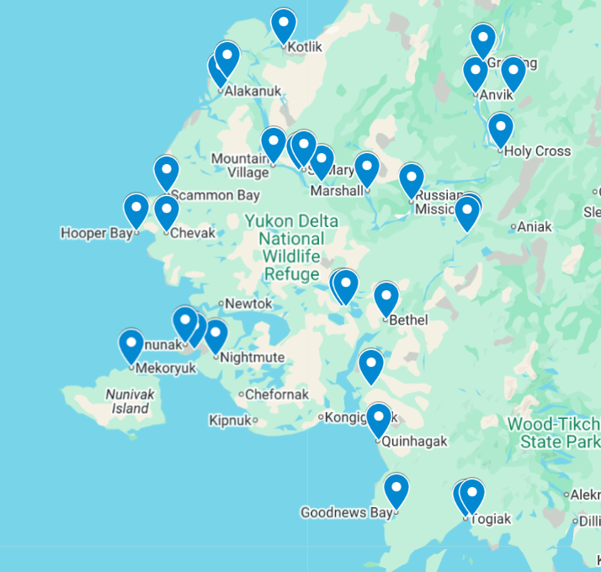

- Renewable Energy Alaska Project (REAP) is an education and advocacy group that promotes renewable energy and energy efficiency.
- Alaska Center for Energy and Power (ACEP) University of Alaska Fairbanks is an applied energy research group providing leadership in sustainable energy systems for islanded, non-integrated electric grids, and heating and transportation systems.

Shipping and Logistics

Crowley

Housing Advocacy Groups – Grassroots organizations advocating for housing improvements.

Alaska-based Non-Profit Organizations

Includes organizations focused on housing, community development, or advocacy for Alaska Native communities.

- Association of Alaska Housing Authorities (AAHA)
- Alaska Native Tribal Health Consortium (ANTHC)
- ANTHC’s Center for Environmentally Threatened Communities has provided technical assistance to numerous YK Delta communities regarding all aspects of protecting in place, managed retreat, and relocation, including assistance with project funding and strategy.
- Catholic Diocese of Fairbanks
- Cold Climate Housing Research Center (CCHRC)
- National Renewable Energy Lab Alaska Campus (NREL)
- Neighborworks AK
- RuralCAP
- Samaritan’s Purse
- Tribal Healthy Homes Network??
- Zender Environmental Group

National Non-Profit Organizations

- Habitat for Humanity https://www.habitat.org/lac-es
- Enterprise Community Partners https://www.enterprisecommunity.org/
- National American Indian Housing Council https://naihc.net/
- TRAD - Tribal Resilience Action Database https://tribalresilienceactions.org/

State Government Agencies

The State of Alaska Division of Community and Regional Affairs (DCRA), and in particular DCRA’s Resilience, Planning, & Land Management Program,

The planning of housing projects often necessitates coordinating activities with state government agencies. Key examples include the need for permits to construct road systems or prepare sites for construction.

- Alaska Department of Transportation (DOT)
- State Departments – Such as the Department of Commerce, Community, and Economic Development.
- State of Alaska Department of Environmental Conservation (DEC)
  - Village Safe Water

Disaster Response
Bethel Search and Rescue (BSAR)

Alaska Division of Homeland Security and Emergency Management
American Red Cross, National Forestry & Inc., and the SEOC

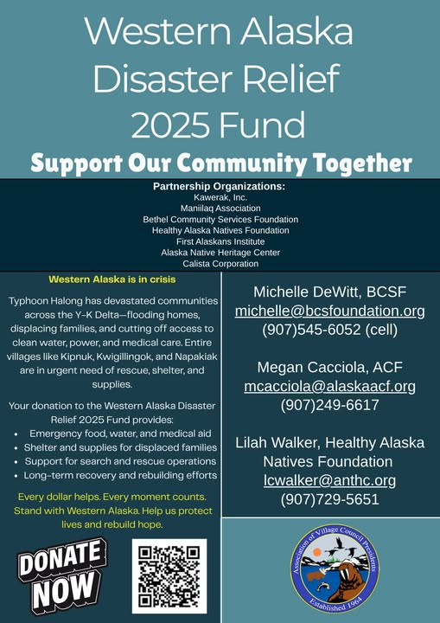

Federal Agencies

Federal agencies are vital sources of funding for housing in the region. They also play a crucial role in shaping federal policies that affect how land and resources are managed. Effective communication between Tribes and communities, agencies, researchers, and federal organizations is essential for addressing the housing needs in the area.

The Denali Commission

The Denali Commission is a federal agency that operates solely in Alaska. It was established by an act of Congress in 1998 (the Denali Commission Act) and provides utilities, infrastructure, and economic support throughout the state, but focuses on Alaska Native communities and, since 2015, has been one of the main agencies assisting communities with climate change adaptation.

provides utilities, infrastructure, and economic support throughout Alaska.^{[1]}

Denali Commission Village Infrastructure Protection
In 2015 the White House directed the Denali Commission to establish a Village Infrastructure Protection (VIP) Program to assist rural Alaskan communities that are threatened by erosion, flooding and permafrost degradation. The goal of the VIP Program is to mitigate the impact of these threats with respect to safety, health and the protection of infrastructure.

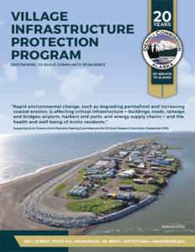

In partnership with ANTHC, the Denali Commission established the Center for Environmentally Threatened Communities (CETC), which supports rural Alaska communities experiencing infrastructure impacts resulting from flooding, erosion, and melting permafrost. Since 2017, CETC staff have worked with 22 communities to address environmental threats and achieve their vision of a safe, healthy, and sustainable future. Their two areas of focus are:
- Securing funding by working closely with communities so they can replace damaged community infrastructure, move homes and community buildings, develop new subdivisions, gain a better understanding of risk, and advance long-term planning.
- Helping to build community capacity to respond to threats by providing grant training and technical assistance.

USGS Climate Adaptation Action Centers

Alaska Climate Adaptation Science Center https://akcasc.org/

Alaska Tribal Resilience Learning Network https://akcasc.org/aktrln/

- U.S. Department of Housing and Urban Development (HUD) – Includes the Office of Native American Programs (ONAP) which was created with NAHASDA as its governing statute in 1996 - are introduced above in the description of tribally designated housing entities.
- U.S. Department of Agriculture (USDA) – Programs like Rural Development Housing.
- Bureau of Indian Affairs (BIA) – Offering support for tribal housing needs.
- Indian Health Service (IHS)
- Environmental Protection Agency (EPA) – Addressing housing impacts on environmental quality.
- U.S. Department of Energy (DOE) – Focused on energy-efficient housing initiatives.
- Environmental Protection Agency (EPA)
- Federal Emergency Management Agency (FEMA) – Supporting housing in disaster-prone areas.
- U.S. Department of Interior (DOI) – Oversight of land management that affects housing projects.

State and Federal Funding Agencies

- Alaska Housing Finance Corporation (AHFC) The state housing agency providing funding and support.
- U.S. Army Corp of Engineers
- Denali Commission
- National Science Foundation (NSF)
- NOAA
- Rasmuson Foundation
- Yukon-Kuskokwim Health Corporation (YKHC)

Relocation Resources

As mentioned above, numerous communities in the YKD are facing retreat or relocation due to environmental risks that are exacerbated by the effects of climate change. Village relocation is an extraordinarily complex and expensive process that requires years if not decades of planning, permitting, and securing funding. A fundamental problem is that there is no single state or federal agency with responsibility for overseeing relocation, thus communities must grapple with the planning and permitting process with numerous agencies. There are only a few modern examples, but it is not uncommon that acquiring land for relocation requires swapping ANCSA corporation land with a federal land management agency, such as the U.S. Fish and Wildlife Service.

The State of Alaska Division of Community and Regional Affairs (DCRA), within the Department of Commerce, Community and Economic Development (DCCED), is directed by two Alaska Administrative Orders ( AO 231 and AO 239) "to act as the state coordinating agency to coordinate with the other state and federal agencies to propose long-term solutions to the ongoing erosion issues in... affected coastal communities...".

The Denali Commission…

The Alaska Native Tribal Health Consortium….

Village relocation in Alaska has also been the subject of numerous academic research projects. Dr. Elizabeth Marino conducted extensive research in the community of Shishmaref for her doctoral dissertation at the University of Alaska Fairbanks Department of Anthropology that sought to understand the process of relocation planning from multiple perspectives. Marino then published a book that is at once an ethnography but can be understood as a sort of guide for Alaska community relocation planning (Fierce Climate, Sacred Ground, 2015) as well as numerous additional articles and book chapters that treat this subject.

Fairbanks-based politician and Executive Director of the Cold Climate Housing Research Center, Mindy O’Neall, based her master’s thesis (UAF, 2017) on a network analysis of the bureaucratic coordination required to address relocation and the state and federal climate and disaster response policies involved in indigenous climate governance.

reliable info on land ownership and jurisdiction. It can be incredibly complicated. The resource I am familiar with is BLM's Spatial Data Management System: https://sdms.ak.blm.gov/sdms/

and BLM's Alaska Case Retrieval Enterprise System (ACRES): https://sdms.ak.blm.gov/acres/acres_menu

And I took a week-long BLM cadastral survey (lands) class, which made it clear why each office at BLM has a realty specialist. They are the only ones who can pull up a master title plat and actually decipher everything on it

Regional Research and Policy Entities

Regional Research Entities – Organizations that study housing and development in Alaska, including think tanks and policy institutes. comm

- Examples needed

Regional Development Organizations

- Examples needed

Academic and Research Institutions
Research institutions are collaborating with state and local stakeholders in Alaska on housing, infrastructure, and related design and building projects. These organizations are often funded by federal agencies and focus on generating both applied and scholarly contributions.

- Georgetown University
- Michigan State University
- Portland State University
- Pratt
- University of Alaska, Anchorage
- University of Alaska, Fairbanks
- University of Buffalo
- University of Virginia
- Virginia Tech

Other Universities and Academic Collaborators

Researchers based outside Alaska who bring valuable expertise to housing-related efforts in the YK Delta. Current projects, though not limited to those listed here, reflect a diversity of approaches and institutional partnerships focused on housing research.

- Examples needed

Other Funding and Financial Entities

- Low-Income Housing Tax Credit
- Enterprise Community Partners (Enterprise Community Investment)
- Private Foundations and Philanthropic Organizations – Providing grants for housing initiatives. Alaska Housing’s innovative Housing Stabilization & Recovery
- Community Development Financial Institutions (CDFIs) – Offering loans and financial support.

Alaska and YKD Housing Data

- AHFC/CCHRC 2018 Housing Assessment and 2025 update
- AVCP RHA Housing Needs Assessment

Implications and Applications

- Design and Implementation Strategies
- Impacts on Stakeholders

Case Studies: Why are they useful?

The variety of organizations and agencies involved in addressing housing needs in remote Alaska is comparable to a river with many tributaries, each contributing to a complex and interconnected system. The activities of these overlapping and often intersecting agencies and service providers are deeply linked to broader societal dynamics, including policy frameworks, cultural practices, and economic pressures. Viewing these connections as a network—one that reflects how housing projects are implemented through the collaboration of people, tools, institutions, and cultural systems—can provide valuable insights.

Siloed work on housing for Quinhagak

To illustrate our point here, we are not trying to simplify individuals, entities, and relations in the following case studies for the benefit of a general audience’s understanding. We are instead illustrating the complexity and the confusion surrounding how even though everyone in Alaska is connected to everyone else, somehow a great deal of work on housing is absolutely siloed. This possible case study illustrates how even in our very small state (population-wise) there’s housing work going on in a small community that others working on housing in that community are not even aware of:

Consultants from a regional housing research non-profit, NorthStar Housing Research (a pseudonym), were tasked to meet with a design team that had reached out to them. That team included an outside funding organization focusing on construction in the North that accommodates indoor agriculture to enhance food security, and which has a presence in several major communities in both Alaska and the Canadian North (Anchorage, AK, Whitehorse, Yukon Territory, and Nunavut). That team had been working with designers from a preeminent design-focused university in the lower 48 to design several new homes for Quinhagak, a small Yupik community in the YKD area. The NorthStar consultants had had a robust relationship with the city mayor of that community over recent years, including her as a key partner in housing studies and networking with her at workshops. The NorthStar team assumed this housing design group had also worked with that mayor, but the design team members had never heard of her and said they were working with the ANCSA corporation from that village.

A few days later, that mayor texted a photo of a building in her town with a specific type of foundation to one of the NorthStar consultants, who have been studying those foundations. They chatted about how the consultant’s former co-worker had gotten a $2M HUD Healthy Homes grant for Quinhagak. The consultant shared what they had learned about the housing design project focused on Quinhagak. The mayor responded that the Corporation staff had not shared information on that project with either the City or the Tribe. This led to a 2-hour long conversation about “trilateral” cooperation in Alaskan communities, which is cooperation between a community’s tribal government, city government, and village ANCSA corporation, with both sharing examples of where and how it had worked and how, in many cases, it does not – usually to the detriment of the community. In this case, the design team working with the corporation was not made aware of any of the work the City had previously done with researchers funded by federal grant who were working on housing designs in that community. This research team included university and regional housing consultants.

Staging areas

Staging areas are used by building crews working on housing construction projects to organize materials for the build. The organization of these materials has many implications on the building process, including improving the efficiency by which needed materials can be identified and transported to the building crew when needed, as well as protection from weather-related impacts. Subsequently, with construction projects in remote communities, considerations for material management - how materials are handled, transported, and stored to facilitate their use and without damage - are critical. Mismanagement can add thousands of dollars to project costs and significantly increase build times, potentially by months or even years.

A staging area refers to the location where the materials for a construction project are stored: it is typically a flat gravel pad that is ideally located to receive materials from barge landings or airstrips, and where materials can be organized to facilitate construction jobs. Having a staging area and having a staging area actually available for use is a prerequisite for a construction project of any size, and many communities do not have adequate staging areas. For building projects to benefit from any economy of scale (e.g., to build several similar homes in one season), a staging area is required.

Home construction support infrastructure needs can be substantial. When construction materials are transported by barge into a community, they usually arrive in a 20- or 40-foot cargo shipping container (usually referred to in Alaska as a Conex), which must be first offloaded to a barge landing, or a temporary initial staging area. Having an adequate barge landing area is critical and not a given. Complete materials for a modest-size home typically require a minimum of four 20’ shipping containers for mechanical, electrical, plumbing, millworks, appliances, etc. and enough additional building materials to fill two 40’ containers.

Next, the materials are moved from the barge landing to a designated staging/storage area. Once the containers are in the staging area, builders and contractors must use four-wheelers or trucks to transport the supplies and equipment needed for different aspects of the project to the building site. Housing projects might be located in multiple sites throughout a village, or they could focus on a single site or new subdivision or neighborhood, such as during a relocation initiative.

Both the organization of materials within the containers and the organization of the containers themselves on the staging area are critical to jobsite efficiency barge to avoid interrupting the organized flow of materials from the staging area to each building site.

When a building construction project is underway, the materials required for the current phase of construction should be arranged in what builders call a laydown area. Laydown areas are specific storage and staging areas within a larger overall staging area where, for example, all the roofing materials are stored and organized.

Project managers have various theories on how best to organize containers and laydown areas, but those with experience in remote housing projects stress the importance of having someone consistently manage the staging area to expedite material management. A foreman for TNHA, the North Slope’s regional housing authority, explained that they do not have the space, staff, or time to manage this in the village where containers land and would be glad to ship containers to a staging area in Fairbanks first where an experienced construction project manager could unpack, inventory, label, and organize all the materials in all the containers to align with the actual sequence of construction before shipping them on to the job site.

The director of the Native Village of Unalakleet Housing Department acquired a large, empty garage that she will use as a staging area for a 10-home weatherization project, and her initial plan was to make distinct piles for each home. (Unalakleet is located on the Norton Sound of the Bering Sea - north of the YKD - but its example is relevant for many YKD communities.) A Fairbanks-based builder suggested instead to “rack out” the entire garage by item type instead, including installing labeled shelves with a corresponding guide for builders.

Though brief, this description highlights the complex relationships involved in developing and using staging areas during home construction. The network includes various actors, from warehouse contractors who load materials at the ports of origin into containers to those responsible for unloading them upon arrival and ensuring safe storage over winter months. Identifying a staging area often requires collaboration among multiple parties within a community, perhaps including the Tribal Council, municipal leaders, and housing authorities. Typically, a village ANCSA Corporation owns the staging area or the land where a staging area can be built, and the cost to acquire and transport gravel and construct the pad is one of the very earliest steps in a remote construction project. Considering this seemingly innocuous aspect of the home construction process and theorizing the relational implications of organizing barge landing, staging areas, and laydown pads areas can play a crucial role in addressing housing security. Enhancing efficiency in this process across the region requires greater attention through research and planning.

Conclusion

- the need to keep this document updated,
- to create resources like this and
- criteria for ensuring such documents are useful to a wide variety of actors and institutions that are involved with housing.

End notes
- Image 1 weblink reference:
  - https://www.avcphousing.org/about/

- Image 2 weblink references:
  - KYUK article: https://www.kyuk.org/science-and-environment/2025-05-29/newtok-was-supposed-to-be-a-model-for-climate-relocation-heres-how-it-went-wrong
  - Propublica article: https://www.propublica.org/article/newtok-alaska-climate-relocation

2020 Napakiak Managed Retreat Project Charter - appendix to Napakiak Managed Retreat Plan https://drive.google.com/file/d/1jkAVMj4U_NDaybi6UjG5aXGumxOWfOWk/view

https://www.avcp.org/about-avcp/our-region/
There are 12 original regional ANCs created with the passage of ANCSA. A 13th ANC was created after the passage of ANCSA to enfranchise Alaska Natives who did not live in Alaska.
https://scholar.google.com/citations?user=2-cdkRgAAAAJ&hl=en
“The State of Climate Change in AK: Agency and Networking of the Governmental Kind” https://research.ebsco.com/c/qg64q2/search/details/nupntsiw3j?q=O%27neall%2C%20mindy
https://www.avcphousing.org/wp-content/uploads/AVCP-RHA-Strategic-Plan-v5-April-update.pdf
CONEX is a portmanteau of “container, express”, a military term for the original shipping containers. Today’s are International Organization for Standardardization (ISO) intermodal shipping containers
Statewide Threat Assessment: Identification of Threats from Erosion, Flooding, and Thawing Permafrost in Remote Alaska Communities Report Prepared for the Denali Commission By University of Alaska Fairbanks Institute of Northern Engineering U.S. Army Corps of Engineers Alaska District U.S. Army Corps of Engineers Cold Regions Research and Engineering Laboratory November 2019
Abrahamson, Mali. 2013. “The Yukon-Kuskokwim Delta A look at the Wade Hampton and Bethel census areas.” https://laborstats.alaska.gov/trends/oct13art1.pdf
https://www.avcphousing.org/wp-content/uploads/AVCP-RHA-Strategic-Plan-v5-April-update.pdf
https://phys.org/news/2025-03-clearer-permafrost-alaska.html

